*TP AND – OR*

Proteus: Porta,0 = 0 y Porta,1 = 0

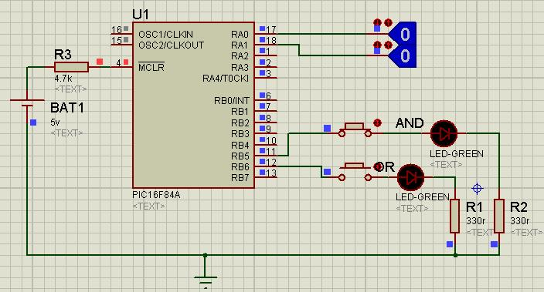

Porta,0 = 0 y Porta,1 = 1

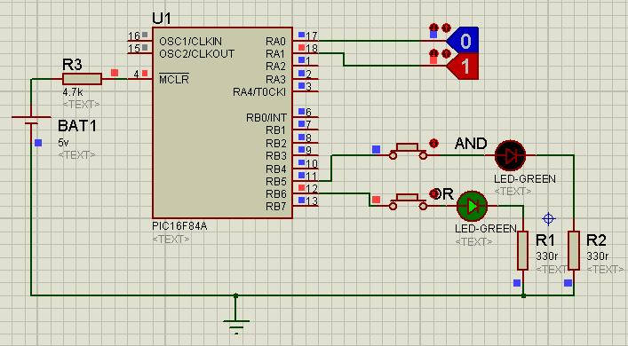

Porta,0 = 1 y Porta,1 = 0

